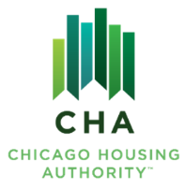
Agenda #: 1

RESOLUTION NO. 2025-CHA-XX

WHEREAS, The Board of Commissioners has reviewed the Board Letter dated September 19, 2025 requesting approval of the FY2026 MTW Annual Plan and authorization to submit the FY2026 MTW Annual Plan to HUD attached hereto;

THEREFORE, BE IT RESOLVED BY THE BOARD OF COMMISSIONERS OF THE CHICAGO HOUSING AUTHORITY:

THAT, The Board of Commissioners hereby approves the FY2026 Moving to Work Annual Plan and grants authorization to the Operating Chairman, or his designee to make any final updates as deemed necessary;

THAT, This approval of the Proposed FY2026 MTW Annual Plan supersedes any and all conflicting language found in prior CHA MTW Annual Plans;
THAT, The Board of Commissioners grants authorization to submit the FY2026 MTW Annual Plan to the U.S. Department of Housing and Urban Development upon Board approval. Such approval shall constitute conclusive evidence of the Board’s approval of any and all such changes.

________________________
James Matanky
Interim Vice Chairman
Chicago Housing Authority

