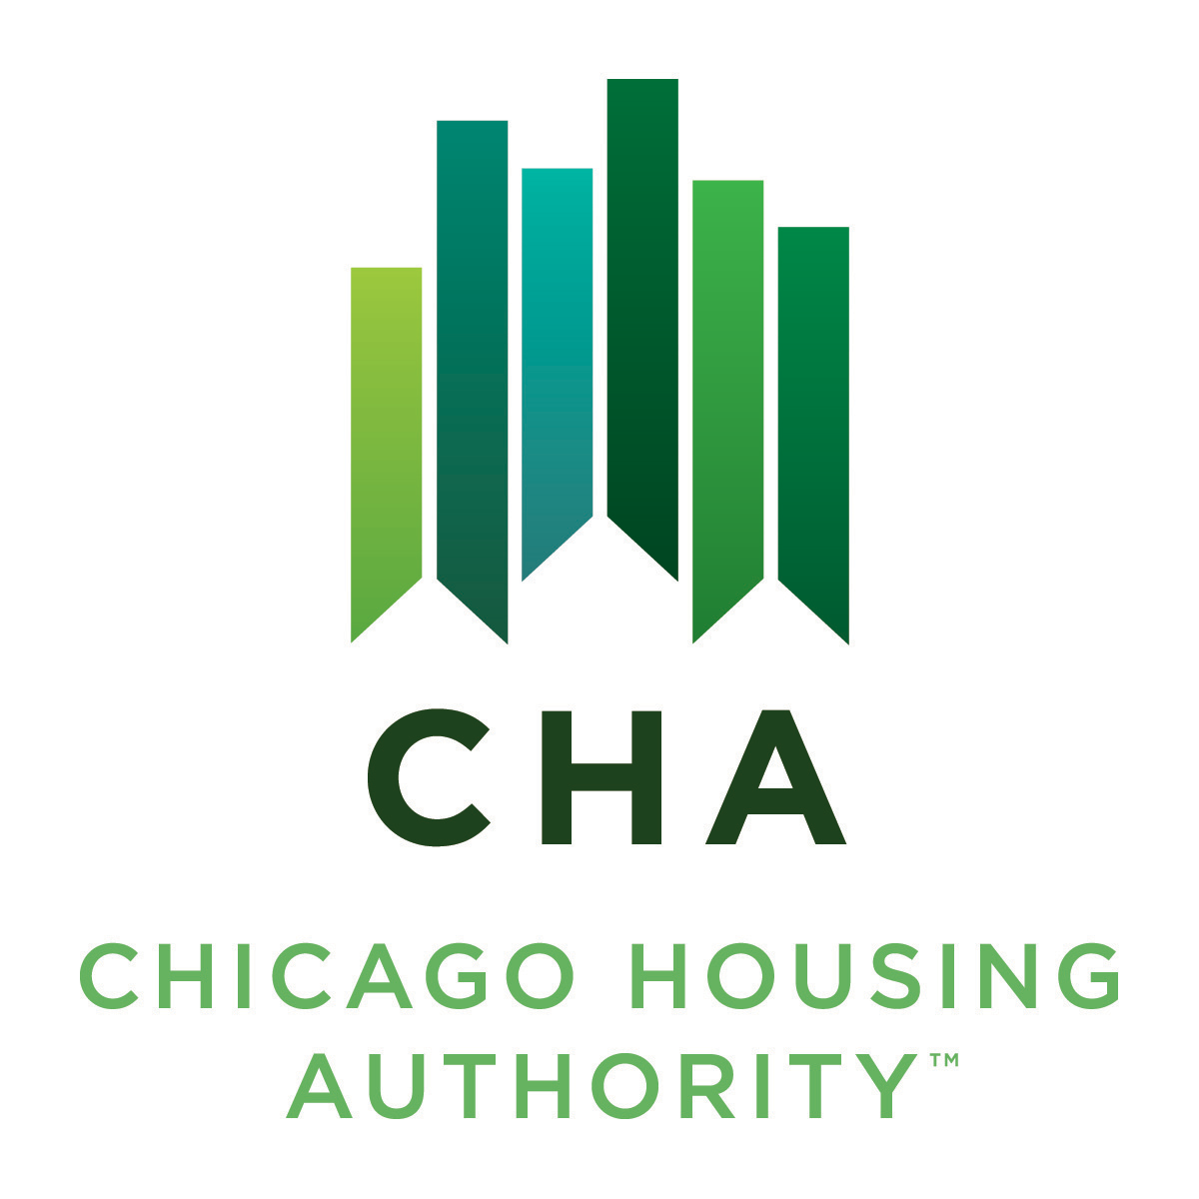

Agenda #: 6

RESOLUTION NO. 2025-CHA-X

WHEREAS, the Board of Commissioners of the Chicago Housing Authority has reviewed the Board Letter dated September 19, 2025, entitled “Authorization to submit a disposition application to the U.S. Department of Housing and Urban Development (“HUD”), enter into a ground lease, and enter into a Power Purchase and Lease Agreement (“PPLA”) for a solar power development at Altgeld Gardens”.

THEREFORE, BE IT RESOLVED BY THE BOARD OF COMMISSIONERS OF THE CHICAGO HOUSING AUTHORITY:

THAT, the Operating Chairman, or his designee, is authorized to submit a disposition application to HUD for the disposition of CHA land located at Parcel - 1 13350 S. Langley Avenue, Parcel 2 – 13325 S. Dobson Avenue, and Parcel 3 – 969 E. 130th Street in Altgeld Gardens;

THAT, the Operating Chairman, or his designee, is authorized upon receipt of HUD disposition approval to enter a 20-year ground lease with two (2) additional 5-year options to extend with Windfree AG Solar 1 LLC, a special purpose entity affiliated with Windfree Wind & Solar Energy Design Company, or its designee;

THAT, the Operating Chairman, or his designee, is authorized, pursuant to the foregoing approval(s) and action(s) to enter into a PPLA with Windfree AG Solar 1 LLC for the supply of renewable electricity at Altgeld Gardens, or its designee; and

THAT, the Operating Chairman, or his designee, shall further have the authority to execute such other documents and perform such actions as may be necessary or appropriate to implement the foregoing.

_________________________
James Matanky
Interim Vice Chairman
Chicago Housing Authority

