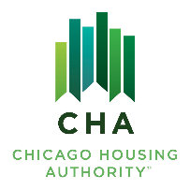

Agenda #: 2

RESOLUTION NO. 2025-CHA-XX

WHEREAS, the Board of Commissioners has reviewed the Board Letter dated September 19, 2025 and attached hereto entitled “Authorization to accept and submit to HUD Chicago Housing Authority’s Financial Statement Audit and Annual Comprehensive Financial Report for the year ended December 31, 2024”.

THEREFORE, BE IT RESOLVED BY THE BOARD OF COMMISSIONERS OF THE CHICAGO HOUSING AUTHORITY

THAT, The Board of Commissioners hereby accepts the Authority’s

      - Financial Statement Audit and Annual Comprehensive Financial Report for The Year Ended December 31, 2024

THAT, The Board of Commissioners hereby authorizes the Operating Chairman or his designee to submit the Financial Statement Audit and Annual Comprehensive Financial Report for the year ended December 31, 2024 to the U.S. Department of Housing and Urban Development.

____________________________
James Matanky
Interim Vice Chairman
Chicago Housing Authority

