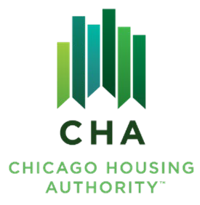

Agenda #: 9
RESOLUTION NO. 2025-CHA-

WHEREAS, The Board of Commissioners of the Chicago Housing Authority has reviewed the Board letter dated September 19, 2025, entitled “Authorization to execute a Housing Assistance Payment (HAP) Contract with a) Paseo 606, b) Branch of Hope, and c) Clara’s Village”.

THEREFORE, BE IT RESOLVED BY THE BOARD OF COMMISSIONERS OF THE CHICAGO HOUSING AUTHORITY:

THAT, The Board of Commissioners authorizes the Operating Chairman, or his designee, to execute an Agreement to enter into a Housing Assistance Payments (AHAP) contract, a corresponding Housing Assistance Payments (HAP) contract and all other documents required for the following developments: a) Paseo 606, b) Branch of Hope, and c) Clara’s Village.

_______________________
James Matanky
Interim Vice Chairman
Chicago Housing Authority

