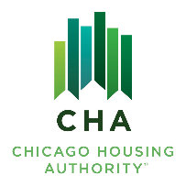
Agenda #: 7

RESOLUTION NO. 2025-CHA-

WHEREAS, the Board of Commissioners of the Chicago Housing Authority has reviewed the Board Letter dated September 19, 2025, entitled “Authorization to select Cabrini New Vision, LLC as the developer partner for the Clybourn and Larrabee site”.

THEREFORE, BE IT RESOLVED BY THE BOARD OF COMMISSIONERS OF THE CHICAGO HOUSING AUTHORITY:

THAT, the Operating Chairman or his designee award Cabrini New Vision, LLC as the developer partner for the Cabrini Clybourn and Larrabee site.

THAT, the Operating Chairman or his designee enter into a Development Agreement for a mixed-finance development with Cabrini New Vision, LLC on the site.

THAT, the Operating Chairman or his designee execute and deliver such other documents and performs such actions as may be necessary or appropriate to implement the foregoing.

This award is subject to the Contractor’s compliance with CHA’s Diversity Contract Compliance and insurance requirements.

____________________________
James Matanky
Interim Vice Chairman
Chicago Housing Authority

