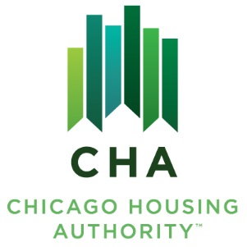

Agenda #: 12
RESOLUTION NO. 2025–CHA-

WHEREAS, the Board of Commissioners has reviewed the Board Letter dated September 19, 2025, entitled “Approval of Personnel Actions”:

THEREFORE, BE IT RESOLVED BY THE BOARD OF COMMISSIONERS OF THE CHICAGO HOUSING AUTHORITY

THAT, the Board of Commissioners hereby approves the requested personnel actions.

______________________
James Matanky
Interim Vice Chairman
Chicago Housing Authority

